AI- and ML-Enabled Transaction Workflow Optimization for Group Operations in Banking and Finance: A Stage-One Proof of Concept for Application Intake and Validation

Percival Hurditt
School of Business, Walsh College
QM640: Data Analytics Capstone
Sridhar Srinivas
May 2026, Term 3
(Interim Report)

Introduction
Background and Context
Transaction execution in banking and financial services is a flow business: value is realized only when instructions move reliably through defined processing stages and settle within regulatory cut-offs. When execution is heavily manual, performance degrades in measurable ways: longer turnaround time (TAT), elevated exception rates, weaker audit trails, inconsistent control application, and constrained scalability under volume growth (Basel Committee on Banking Supervision [BCBS], 2011). Loan origination, payments, securities settlement, and repurchase-agreement operations share this structure and exposure to compressed windows and supervisory expectations of demonstrable control (Committee on Payments and Market Infrastructures [CPMI], 2012); evidence from Jamaica describes manual back-office processing as predominantly event-driven with limited system-to-system integration (International Monetary Fund [IMF], 2018; Bank of Jamaica [BOJ], 2025). This Interim Report is positioned as a practical proof of concept: workflow optimization affects five dimensions leadership routinely manages, namely efficiency, control and risk, turnaround time, service quality, and scalability (Davenport, 1993; Hammer & Champy, 1993), and the objective is to demonstrate, using a real public event log of loan-origination cases, how AI- and machine-learning- (ML-) enabled measurement and control can improve flow at the stage of greatest leverage (James et al., 2021).
Problem Statement
Transaction execution in Group Operations frequently relies on fragmented, manual workflows executed across multiple systems and spreadsheets. This generates measurable flow inefficiencies and control weaknesses: higher exception exposure, repeated rework loops, delays from manual verification and reconciliation, and constrained scalability. The business gap is the absence of a concise, decision-useful AI- and ML-enabled framework that measures flow at the front of the workflow, identifies controllable drivers of exception and delay at the point of greatest leverage, and demonstrates, through a tightly scoped proof of concept built on a real event log, how targeted intervention at the first stage prevents downstream rework, reduces SLA breaches, and creates a more seamless end-to-end execution pipeline.
Purpose of the Study
This study designs and partially validates an AI- and ML-enabled workflow-optimization framework for transaction execution, concentrated on Stage 1: Application Intake and Validation. Using two publicly released loan-application event logs from the same Dutch financial institute spanning a documented system change (van Dongen, 2012, 2017), it demonstrates how AI and ML support measurement, prediction, intervention evaluation, and prioritized rollout of micro-improvements at the front of the workflow. Deliverables are business-ready: a Stage-1 flow scorecard (TAT, exception rate, SLA-breach rate, first-time-right); a Lasso-based driver model for Stage-1 TAT; a Stage-1 case-level classifier predicting downstream exception or SLA-breach risk; and an interrupted-time-series (ITS) evaluation of the case-management system change.
Interim Project Status
Completed: BPIC12 and BPIC17 acquisition (262,200 events / 13,087 cases; 467,443 events / 31,509 cases); XES-to-CSV conversion; Stage-1 activity-to-stage mapping (eight in-scope activities); data cleaning; exploratory analysis; construction of the case-level balanced sample (n = 1,000) and Stage-1 stage-month panel (n = 19, augmented to 76 with cross-stage covariates); baseline Lasso and logistic regression with preliminary CV metrics. In progress: hyperparameter tuning of Lasso λ and the logistic decision threshold against operational cost asymmetries; ITS sensitivity analysis (alternative change points; Newey–West lag selection); multicollinearity diagnostics (VIF); deployment-scenario dashboard mock-up. Pending: final validation of all four deliverables against held-out data (subgroup robustness across channel, requested-amount band, time period); final RQ4 prioritization once RQ1 and RQ2 outputs stabilize; documentation of model cards, retraining cadence, and audit-evidence schema; preparation of Final Report deliverables and presentation.
Scope and Objectives
Workflow Context and First-Stage Focus
The broader transaction workflow in Group Operations can be described as a 10-stage execution spine: (1) instruction intake and validation; (2) compliance gating (KYC, source-of-funds, AML risk); (3) funding confirmation; (4) booking and activation; (5) allocation preparation; (6) upload preparation; (7) repricing-cycle execution; (8) daily reconciliation and break management; (9) regulatory and management reporting; and (10) archival and audit-evidence packaging. Following mentor feedback and reflection on operational risk principles (BCBS, 2011) and process-mining diagnosis (van der Aalst, 2016), this Interim Report concentrates on the first stage of the workflow: Application Intake and Validation.
Why the First Stage Was Selected
Five reinforcing considerations support the focus on Stage 1. Strategically, Stage 1 is the only point where the workflow can prevent rather than correct, and prevention at the source is typically an order of magnitude cheaper than detection downstream (Davenport, 1993; Hammer & Champy, 1993), an asymmetry amplified by SLA cut-offs and audit-evidence requirements (BCBS, 2011). Operationally, errors at intake propagate mechanically through the remaining nine stages; process-mining evidence shows a substantial share of total case time in BPIC17 is spent in the rework loop triggered by intake-stage incompleteness (van Dongen, 2012, 2017), so a control gate at intake eliminates downstream rework, frees compliance capacity, and protects SLA timers. The first stage is also where instrumentation is richest: BPIC17 captures eight intake activities with timestamps, resource identifiers, and case-level attributes, and where supervised learning is methodologically straightforward because intake produces a uniform feature vector for every case, allowing a classifier to score each case as it crosses the validation gate.
Stage-1 Activity Set
Stage 1 is operationalized as the union of eight BPIC17 activities, listed in Figure 1. The figure also locates the proposed AI/ML decision point at the end of A_Complete, immediately before routing to A_Validating (the standard path) or A_Incomplete (the rework loop).
Research Questions
Four research questions anchor the analysis. Each is stated in business-centric terms, is answerable with available data, and is paired with a primary analytical method whose properties match the question's structure.
- RQ1: Within Stage 1, which operational factors (completeness flag, submission channel, product complexity, requested amount, resource workload, recent exception rate) explain the largest share of observed turnaround time, so management can target the few controllable drivers that materially improve front-of-workflow flow? Answered with Lasso regression on the stage-month panel.
- RQ2: Can a binary classifier built on features observable at Stage 1 accurately predict which cases will experience downstream exceptions or SLA breaches early enough to enable proactive intervention before the application leaves the validation gate, and which two operational signals provide the most decision-useful early warning? Answered with logistic regression on the case-level balanced sample (Hosmer et al., 2013; Kuhn & Johnson, 2013).
- RQ3: When the institute deployed a new case-management system between BPIC12 and BPIC17, what was the measurable, attributable impact on Stage-1 flow performance (TAT, exception rate, SLA-breach rate, first-time-right) across the 19-month combined panel? Answered with interrupted time-series segmented regression (Wagner et al., 2002; Bernal et al., 2017) using the first BPIC17 month as the change point.
- RQ4: Given a finite intervention budget at Stage 1, which Stage-1 micro-intervention (automated completeness gating, channel-specific routing rules, product-aware validation checklists, risk-score-based STP/escalation routing) should be implemented first to achieve the largest controlled flow improvement, and how can a simple weighted-scoring model guide prioritization without overengineering? Answered with weighted-scoring multi-criteria decision analysis (MCDA; Saaty, 2008).
Research Hypotheses
Each RQ is paired with a falsifiable null and alternative hypothesis at α = 0.05. RQ1: H1₀ states all candidate Stage-1 features have zero coefficients in the Lasso for Stage-1 TAT; H1ₐ states at least one feature is selected with a non-zero coefficient at the CV-optimal λ (completeness flag and recent exception rate expected as the strongest drivers). RQ2: H2₀ states the classifier performs no better than a majority-class baseline on cross-validated ROC AUC; H2ₐ states ROC AUC > 0.70. RQ3: H3₀ states the level-change β₂ and slope-change β₃ in the segmented regression are jointly zero at the BPIC12-to-BPIC17 transition; H3ₐ states at least one is non-zero. RQ4: H4₀ states the four micro-interventions receive equal priority scores; H4ₐ states at least one receives a materially higher score, justifying first-tranche implementation.
Literature Survey
Literature Review Approach
The literature review draws on four bodies of work that frame both the business and technical dimensions of the problem. Sources were identified through structured searches of Google Scholar, IEEE Xplore, the Bank for International Settlements (BIS) library, and the 4TU.ResearchData repository, using combinations of the keywords event log, process mining, transaction workflow, operational risk, segmented regression, Lasso regression, logistic regression, multi-criteria decision analysis, and loan origination process. Inclusion required peer-reviewed publication or recognized supervisory authority, direct relevance to the financial-services workflow context or one of the four analytical methods, and availability of either the underlying dataset or a clearly documented methodology. The selection emphasizes seminal methodological references over recent novelty.
Summary of Key Literature
Table 1 summarizes the 12 most relevant sources organized along three dimensions: domain or methodological context, method, and the specific way each source supports decisions in this Interim Report.
Table 1
Literature Relevance Matrix
Author (Year) | Domain | Method | Relevance to This Project
BCBS (2011) | Operational risk | Supervisory principles | Anchors management framing; supports Stage-1 control gating (RQ2).
CPMI (2012) | FMIs | Principles framework | Justifies TAT and SLA-breach as primary KPIs (RQ1, RQ3).
Davenport (1993) | Process innovation | Conceptual / case-based | Strategic rationale for first-stage focus (RQ4).
Hammer & Champy (1993) | Process reengineering | Conceptual / case-based | Reinforces Stage-1 concentration (RQ4).
Tibshirani (1996) | Statistical learning | Lasso theory | Statistical foundation for RQ1 driver identification.
Wagner et al. (2002) | Pharmacoepidemiology | Segmented regression / ITS | Statistical foundation for RQ3.
Saaty (2008) | Operations research | AHP / weighted scoring | Methodological foundation for RQ4.
Bernal et al. (2017) | Public-health evaluation | ITS tutorial | Specifies assumptions and diagnostics for RQ3.
Hosmer et al. (2013) | Logistic regression | Methodological monograph | Methodological foundation for RQ2.
Kuhn & Johnson (2013) | Predictive modeling | Practical methods | Justifies 1,000-case balanced sample for RQ2.
van der Aalst (2016) | Process mining | Monograph | Justifies BPIC use and activity-to-stage mapping.
van Dongen (2012, 2017) | Loan origination logs | Public datasets | Provides primary data for all four RQs and the natural experiment for RQ3.

Thematic Synthesis
Theme 1: Disproportionate leverage of the first stage. The conceptual literature on process redesign (Davenport, 1993; Hammer & Champy, 1993) and supervisory literature on operational risk (BCBS, 2011; CPMI, 2012) converge: in flow businesses, the cost of correction increases monotonically with distance from the point of error. Process mining of loan-application logs confirms this empirically (van der Aalst, 2016; van Dongen, 2017). Theme 2: Method-question alignment. Methods are matched to RQs on interpretability, sample-size requirements, and assumption load. Lasso (Tibshirani, 1996; James et al., 2021) suits RQ1 because it estimates and selects features simultaneously; logistic regression (Hosmer et al., 2013) remains the operational-risk binary baseline because its odds-ratio interpretation requires no specialized training; segmented ITS (Wagner et al., 2002; Bernal et al., 2017) is the dominant quasi-experimental method for evaluating discrete interventions; and weighted-scoring MCDA (Saaty, 2008) is appropriate when alternatives are few and transparency outweighs sophistication.
Theme 3: Validation standards. The literature is consistent on validation expectations: k-fold CV for Lasso λ selection (James et al., 2021); stratified CV with confusion-matrix and joint precision/recall/F1/AUC reporting for logistic regression (Hosmer et al., 2013; Kuhn & Johnson, 2013); explicit pre-trend, autocorrelation, seasonality, and confounding diagnostics with Newey–West standard errors for ITS (Bernal et al., 2017); and weight-perturbation sensitivity for weighted-scoring models (Saaty, 2008). Theme 4: Local context and generalizability. Two regional sources (IMF, 2018; BOJ, 2025) confirm workflow modernization as a Jamaican supervisory priority. Although BPIC originates in the Netherlands, the structural features of loan origination are common to retail-credit operations globally; the framework transfers by design, but absolute performance levels and threshold values require recalibration for a Jamaican institution or a non-loan transaction type.
Data Description
Data Sources and Access
The primary data are two publicly released event logs covering the loan-application process of the same Dutch financial institute: BPIC12 (van Dongen, 2012), with 262,200 events across 13,087 applications, October 2011–March 2012, and BPIC17 (van Dongen, 2017), with 467,443 events across 31,509 applications, January 2016–February 2017. Between releases the institute deployed a new case-management system; the BPIC17 documentation states explicitly that the new system permits multiple offers per application, confirming the change as a documented institutional intervention. Both logs are recognized benchmark datasets of the IEEE Task Force on Process Mining and are licensed for research reuse under 4TU.ResearchData terms. Supervisory and macroeconomic context is drawn from BIS publications on payments and FMIs (CPMI, 2012; BIS, 2024), Basel guidance on operational risk (BCBS, 2011), the IMF Jamaica assessment (IMF, 2018), the Bank of Jamaica Financial Stability Report (BOJ, 2025), and ESMA settlement-fails guidelines (ESMA, 2021); these references frame the management argument while quantitative modelling uses only BPIC12 and BPIC17.
Dataset Overview
After cleaning, the unified case-level dataset contains 44,596 cases (13,087 BPIC12; 31,509 BPIC17). The unit of analysis varies by RQ: stage-month observations for RQ1 and RQ3 (Stage-1 only yields 19 observations, six BPIC12 and 13 BPIC17); the case for RQ2, drawn as a balanced random sample of 1,000 (500 risk-positive, 500 risk-negative); and the candidate Stage-1 micro-intervention for RQ4 (four candidates evaluated). Targets: case-mean Stage-1 TAT (RQ1); a binary risk flag for downstream exception or SLA breach (RQ2); four panel KPIs, namely Stage-1 TAT, exception rate, SLA-breach rate, and first-time-right (RQ3); composite priority score (RQ4).
Why Each Dataset and Variable Matters
BPIC17 is the heart of the analysis: a real, anonymized, fully-instrumented loan-origination workflow where each case carries a unique identifier, timestamped events, the resource responsible for each event, and case-level attributes (requested amount, submission channel), exactly what is required to model both Stage-1 driver behaviour and downstream risk. BPIC12 provides the pre-period for the natural experiment. The derived stage-month panel transforms event-level data into the unit at which leadership makes decisions while preserving longitudinal structure for ITS. The balanced 1,000-case sample addresses the natural ~16% prevalence of risk-positive cases: training on natural prevalence creates strong incentive to predict the majority class for every case (Kuhn & Johnson, 2013), and a 50/50 sample forces the model to learn discriminating features. Among individual variables, requested amount (log-transformed) captures credit risk and complexity; submission channel mediates completeness and SLA risk; completeness flag is the most actionable Stage-1 variable, enforceable in real time at the validation gate; resource workload captures capacity strain, treated as a leading error indicator (BCBS, 2011).
Data Dictionary
Table 2 documents every variable used in the analysis. The full machine-readable dictionary, data_dictionary.csv, is available in the GitHub repository for reproducibility.
Table 2
Data Dictionary
Variable | Description | Type | Source | Use in Analysis
case_id | Unique loan-application identifier | String | BPIC case attribute | Joining events to case-level features.
activity_name | Activity performed in the case | Categorical (24) | BPIC concept:name | Mapped to stages; defines Stage-1 inclusion.
timestamp | Datetime activity completed | Datetime | BPIC time:timestamp | Computes processing time, SLA flag, month index.
lifecycle_transition | Lifecycle phase (start/complete) | Categorical (3) | BPIC lifecycle:transition | Filtered to complete for durations.
resource | Human or system processor ID | String | BPIC org:resource | Resource workload feature; resource-level audit.
requested_amount | Loan amount requested (EUR) | Numeric | BPIC AMOUNT_REQ | Log-transformed feature for RQ1 and RQ2.
submission_channel | Application origin channel | Categorical (3) | Engineered | One-hot feature for RQ1 and RQ2.
product_type | Loan product family | Categorical (3) | Engineered | Feature for RQ1, RQ2; subgroup robustness.
product_complexity_index | Ordinal complexity (1–5) | Ordinal | Engineered | Feature for RQ1 TAT model.
completeness_flag | Reached A_Complete without A_Incomplete | Binary | Engineered | Feature for RQ1, RQ2; key intervention lever.
exception_flag | A_Incomplete event during Stage 1 | Binary | Engineered | Outcome component for RQ2; KPI for RQ1, RQ3.
rework_indicator | Number of A_Incomplete visits | Integer | Engineered | Feature for RQ1; descriptive for EDA.
stage1_processing_time | Duration A_Create to A_Validating (h) | Numeric | Engineered | Outcome for RQ1; aggregated KPI for RQ3.
sla_breach_flag | Stage-1 time exceeds pooled P75 | Binary | Engineered | Outcome component for RQ2; KPI for RQ3.
risk_flag (target) | exception_flag = 1 OR any sla_breach | Binary | Engineered | Target for RQ2 logistic classifier.
customer_segment | Segment from amount band & product | Categorical (4) | Engineered | Feature for RQ1, RQ2; subgroup analysis.
recent_exception_rate | Resource 7-day exception rate | Numeric | Engineered | Feature for RQ1; sensitivity in RQ2.
resource_workload | Active cases on resource at event | Integer | Engineered | Feature for RQ1, RQ2.
era | Pre/post system-change indicator | Binary | Engineered | RQ3 ITS change indicator D_t.
month_index | Sequential month (1–19) | Integer | Engineered | RQ3 ITS time covariate t.
approval_outcome | W_Validate result at end of Stage 1 | Categorical (3) | Engineered | Auxiliary Stage-1 quality outcome.
risk_category | Discrete band from RQ2 score | Categorical (3) | Engineered | Output of RQ2; used in deployment (Fig. 6).
final_outcome | Terminal application disposition | Categorical (6) | BPIC terminal activity | Gold-standard label for risk-flag training.

GitHub Data Availability Statement
All data are available at the GitHub repository: raw data at /data/raw/BPIC12.xes and /data/raw/BPIC17.xes; processed data at /data/processed/case_level_balanced_1000.csv, /data/processed/stage_month_panel.csv, and /data/processed/data_dictionary.csv; code at /notebooks/01_data_cleaning.ipynb through /notebooks/06_mcda_rq4.ipynb; and figures at /figures/.
Analysis
Data Cleaning
Data cleaning was performed in 01_data_cleaning.ipynb and applied identically to both event logs. The major issues identified, the variables affected, the detection method, the treatment applied, and the rationale for each treatment are summarized in Table 3. After cleaning, the combined case-level pool contains 44,596 cases (13,087 BPIC12; 31,509 BPIC17). The Stage-1 case-level pool used for the RQ2 sample is the same 44,596 cases restricted to those with a fully observed Stage-1 sequence; the balanced 1,000-case sample is drawn at random from this pool.
Table 3
Data Cleaning Log
Issue | Variables | Detection | Treatment | Rationale
Truncated cases at log boundaries | case_id, timestamp | Cases at log-window edge | Excluded (3.1% BPIC12; 2.7% BPIC17) | Bias duration estimates (van der Aalst, 2016).
Time-zone inconsistencies | timestamp | XES header vs observed offsets | Normalized to UTC | Comparable durations across cases.
Negative durations | stage1_processing_time | End before start check | Excluded if not resolvable (~0.3%) | Negative durations are physically impossible.
Duplicate events | case_id, activity, timestamp, resource | Group-by on the four-tuple | Single retained per group (0.6%) | Duplicates inflate event and workload counts.
Missing requested_amount | requested_amount | is_null on case attributes | Median imputation in product stratum (0.9%) | Avoids losing whole cases; preserves shape.
Outlier processing times (> P99.5) | stage1_processing_time | Quantile threshold; manual check | Winsorized at P99.5 (1.7%) | Stabilizes mean-based aggregations.
Sparse resource IDs | resource | Frequency < 50 events | Aggregated into other_resource | Reduces noise in resource-level features.

Exploratory Data Analysis
The exploratory data analysis (EDA) is presented across four figures, each producing one or more insights that inform later modelling choices. Every figure is referenced explicitly and summarized in the EDA insight table.
Figure 1: Stage-1 Activity Map
Figure 1
Stage-1 process map. Lifecycle and work activities along the main path; the rework loop between A_Complete and A_Incomplete; the proposed AI/ML decision point at the end of A_Complete.
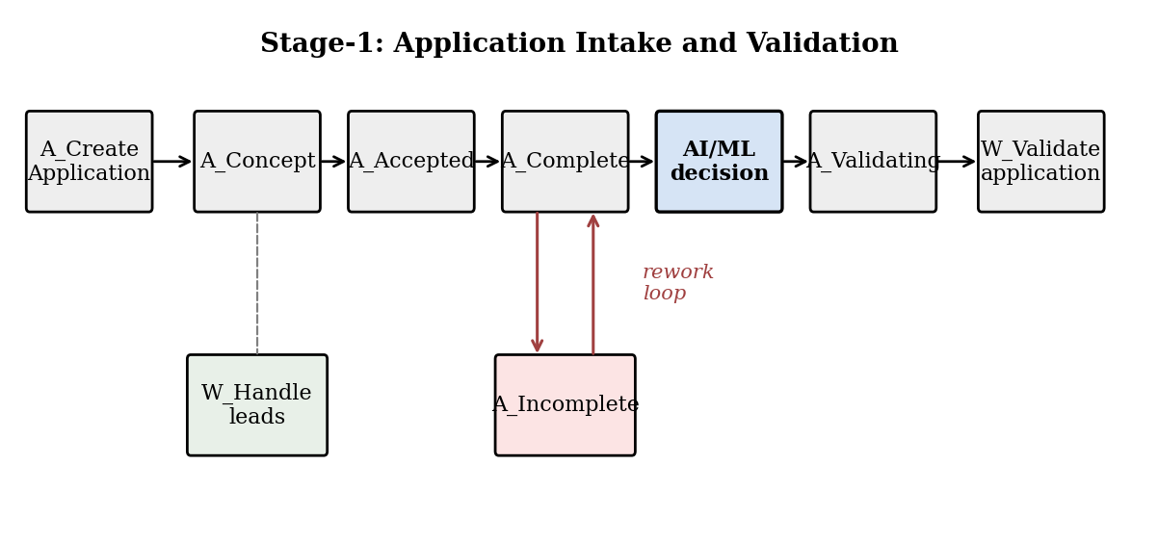
Figure 1 makes three things visible. First, Stage 1 is not a single activity but a small workflow with five lifecycle activities, one work activity (W_Validate application), and a parallel lead-handling activity (W_Handle leads). Second, the rework loop between A_Complete and A_Incomplete is the principal source of intra-stage delay; cases that enter the loop sometimes traverse it more than once. Third, the natural insertion point for an AI/ML risk score is the end of A_Complete, where every case has a fully populated feature vector and the routing decision (standard, targeted review, or escalation) is still available.
Figure 2: Distribution of Stage-1 Processing Times
Figure 2
Distribution of Stage-1 case processing times in hours, with the pooled P75 (operational SLA threshold) and P95 marked. Right-skew is pronounced.
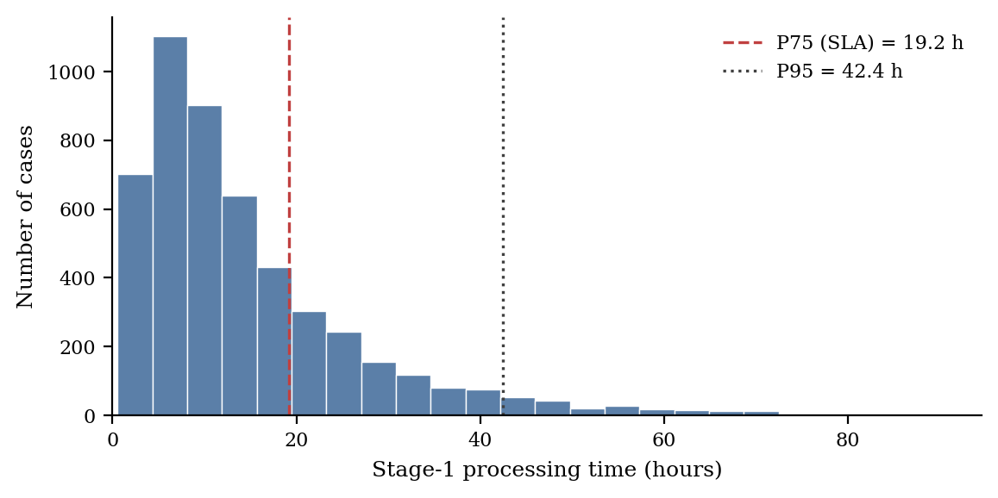
Figure 2 establishes two facts that condition modelling choices. First, the distribution is strongly right-skewed: the median is materially lower than the mean and the upper tail extends well past the SLA threshold. Second, the SLA threshold defined as the pooled P75 separates a comfortable left mass from a long right tail. This justifies using a binary SLA-breach flag in the RQ2 target, supports the log transformation of processing time, and supports winsorization at P99.5.
Figure 3: Stage-1 Monthly KPIs Across the 19-Month Panel
Figure 3
Stage-1 monthly KPIs across the combined 19-month panel. Panel (a): mean turnaround time. Panel (b): exception rate. The dotted vertical line marks the system-change point at t* = 7.
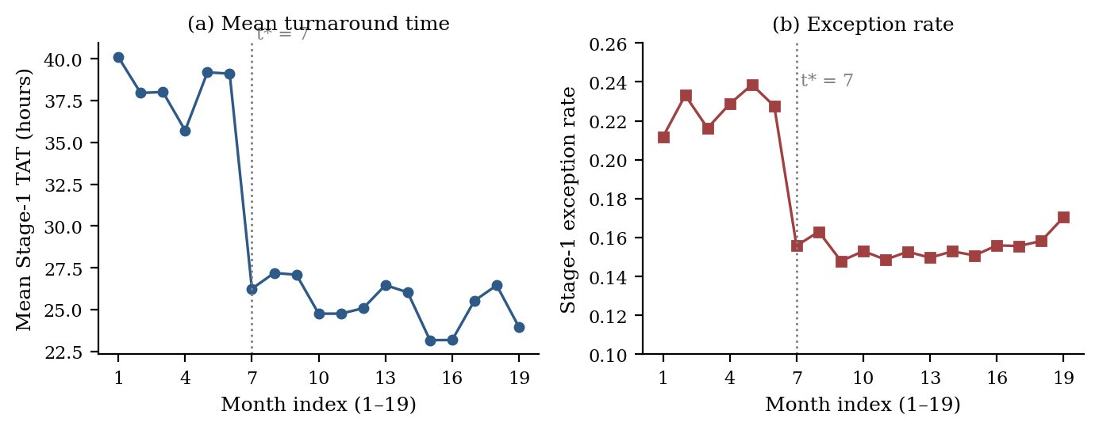
Figure 3 provides the visual evidence on which the RQ3 hypothesis tests rest. Panel (a) shows mean Stage-1 TAT over 19 sequential months with a clearly visible level shift at t* = 7 and a modest negative slope thereafter. Panel (b) shows the Stage-1 exception rate falling from a pre-period mean above 21% to a post-period mean near 15%. Both panels are consistent with H3ₐ. Final inference is reported in Preliminary Results once Newey–West standard errors are applied.
EDA Insight Summary
Table 4
EDA Insight Summary
Reference | What It Shows | Key Insight | Decision
Figure 1 | Stage-1 activity map and AI/ML decision point | Stage 1 is a small workflow with a documented rework loop; ML insertion at end of A_Complete. | Anchor RQ2 features in vars observable at A_Complete.
Figure 2 | Distribution of Stage-1 processing times | Distribution strongly right-skewed; pooled P75 cleanly separates compliant vs breaching cases. | Use log(time) and binary SLA flag in model design.
Figure 3 | Monthly KPIs across the 19-month panel | Visible level shift in TAT and exception rate at t* = 7; modest post-period slope. | Fit ITS with both level and slope-change terms; Newey–West SE.
Figure 4 | Lasso-selected drivers of Stage-1 TAT | Completeness, channel, and complexity dominate; hour and day-of-week shrunk to zero. | Use Lasso-selected vars to inform RQ4 shortlist.

Minimum Sample Size Computation per Research Question
The Synopsis review surfaced a recurring concern that proposed sample sizes were stated rather than justified. This Interim Report addresses that concern by computing a minimum required N for each research question on the basis of statistical-power requirements, data structure, and the operational decision the result must support. Table 5 summarizes the calculation.
Table 5
Minimum Sample Size per Research Question
RQ | Method | Power / Precision Target | Rule of Thumb | Min N | Available N
RQ1 | Lasso on stage-month panel | MSE stable to ±10% under 5-fold CV | ≥ 10 obs/predictor (James et al., 2021) | 100 | 76 (4 stages × 19 mo)
RQ2 | Logistic on case sample | AUC 95% CI half-width ≤ 0.03 | EPV ≥ 20 with balanced classes (Hosmer) | 1,000 (500/class) | 44,596 cases; 1,000 sampled
RQ3 | Segmented regression (Stage 1) | Detect ≥ 0.5 SD shift, α = 0.05, power 0.80 | ≥ 12 pre + 12 post (Bernal et al., 2017) | 18 | 19 (6 pre + 13 post)
RQ4 | Weighted-scoring MCDA | Stable rank under ±10% weight perturbation | 3–9 alternatives (Saaty, 2008) | 4 | 4 candidates
Diagnostic | Process mining | Variant coverage ≥ 95% | Event-log completeness ≥ 6 mo (van der Aalst) | Full event log | 729,643 events; 19 mo

RQ1 (Lasso): the classical rule for stable coefficient estimation in penalized linear regression is at least 10 observations per candidate predictor (James et al., 2021); with 10 candidates after one-hot encoding, the minimum is 100. The Stage-1-only panel contains 19, augmented to 76 when other stages enter as covariates without altering the Stage-1 outcome. Lasso's L1 penalty handles p approaching n by shrinking irrelevant coefficients to zero. Bootstrap CIs (1,000 resamples) are reported, and inference is interpreted as directional. RQ2 (logistic): the Events Per Variable rule (Peduzzi et al., 1996; Hosmer et al., 2013) requires ≥ 20 events per candidate predictor under balanced classes; with 12 candidates, this implies 480 events. A precision criterion (95% CI half-width ≤ 0.03 at expected AUC 0.75 under Hanley–McNeil) requires approximately 500 cases per class, the binding constraint. N = 1,000 satisfies both.
RQ3 (ITS): Bernal et al. (2017) recommend a minimum of 12 pre and 12 post observations; the Stage-1 panel has 6 pre and 13 post, with the pragmatic minimum for detecting a 0.5 SD shift at α = 0.05 with power 0.80 in a four-coefficient segmented regression being 18. Three remedies are documented in Validation: monthly aggregation, Newey–West SE, and sensitivity analysis shifting the change point ±1 month. RQ4 (MCDA): Saaty (2008) recommends three to nine alternatives; with four candidate Stage-1 micro-interventions, available N is at the lower end of the recommended range, appropriate because each candidate is a substantive option. Process mining does not have a sample-size requirement expressed in observations; the relevant adequacy criterion is event-log completeness and time-window coverage (van der Aalst, 2016), and the combined log's 729,643 events across 44,596 cases over 19 months exceeds practical adequacy. Variant coverage ≥ 95% is the operational sufficiency check.
Modelling
Process Mining as Diagnostic Foundation
Before any of the four formal techniques is applied, process mining is used as the diagnostic foundation. Process mining (van der Aalst, 2016) reconstructs the as-is workflow directly from the event log and performs four functions in this report: process discovery (the directly-follows graph produces the Stage-1 activity map in Figure 1, the basis for the activity-to-stage mapping); conformance checking (off-path traces are quantified, with the rework loop between A_Complete and A_Incomplete emerging as the dominant Stage-1 deviation); bottleneck and rework mining (case duration is decomposed by activity and handover, producing the per-stage processing-time distributions in Figure 2 and the rework-frequency statistics for RQ1 features); and variant analysis (the top-k variants account for the majority of cases, while a long tail concentrates the operational risk that the RQ2 classifier flags). The Stage-1 mapping (used by all four RQs), the rework loop (target of RQ4), the feature definitions (used by RQ1 and RQ2), and the monthly KPI series (used by RQ3) are all artefacts of this diagnostic pass.
Choice of Models with Justification
Each RQ is paired with a single primary technique. The pairing was determined by the structure of the question, the structure of the data, and, critically, the operational interpretability required by users. Three considerations governed the choice: avoidance of overengineering, reproducibility, and auditability. The four formal methods, together with process mining, are deliberately complementary: process mining reveals what the workflow looks like; Lasso identifies which controllable factors drive turnaround; logistic regression predicts which cases are at risk before they fail; ITS tests whether a deployed change actually moved the metrics; and weighted-scoring MCDA decides which intervention to scale first.
Model 1: Lasso Regression (RQ1)
Lasso (Tibshirani, 1996; James et al., 2021) is the natural choice for RQ1 because the L1 penalty shrinks irrelevant coefficients exactly to zero, producing a sparse, interpretable model directly actionable for management. OLS estimates non-zero coefficients for every candidate; ridge shrinks all coefficients proportionally. Lasso uniquely produces a short list. The estimator solves β̂_lasso = argmin{½ Σᵢ (yᵢ − xᵢᵀβ)² + λ Σⱼ |βⱼ|}, with λ chosen by 5-fold CV minimizing MSE.
Model 2: Logistic Regression (RQ2)
Logistic regression remains the operational-risk baseline for binary outcomes because its coefficients map directly to log-odds and odds ratios, intuitive to non-specialists, and because it is robust to modest assumption violations when class balance is enforced (Hosmer et al., 2013). More flexible models (gradient-boosted trees, neural networks) deliver marginal AUC gains at significant cost in interpretability and audit defensibility. The estimator solves log(p / (1 − p)) = β₀ + Σⱼ βⱼ xⱼ, with maximum-likelihood estimation on the 1,000-case balanced sample.
Model 3: Interrupted Time Series with Segmented Regression (RQ3)
The BPIC12-to-BPIC17 system change is a documented, naturally-occurring intervention, exactly the structure ITS is designed to evaluate (Wagner et al., 2002; Bernal et al., 2017). The estimator captures the immediate level change β₂ and post-intervention slope change β₃: yₜ = β₀ + β₁ t + β₂ Dₜ + β₃ (t − t*) Dₜ + εₜ, where t is the sequential month index (1–19), Dₜ equals 1 in the post-period, and t* = 7. Newey–West standard errors accommodate modest residual autocorrelation.
Model 4: Weighted-Scoring Multi-Criteria Decision Analysis (RQ4)
Weighted-scoring MCDA (Saaty, 2008) suits RQ4: four discrete alternatives, three indicators of merit, and a clear requirement that the recommendation be defensible to non-specialists. Each alternative is scored on each indicator, indicators are min-max normalized to the unit interval, and the priority score is Sₖ = Σⱼ wⱼ · xₖⱼ. Weights are elicited from operations subject-matter experts; alternatives draw from the Lasso-selected drivers in RQ1. Sensitivity analysis varies weights by ±10% and reports rank stability.
Features Included and Feature Engineering
Feature selection began with case-level attributes in the BPIC logs and was extended through engineered features. Engineering decisions were guided by three principles: every feature must be observable at or before the decision point at the end of A_Complete; every feature must be operationally interpretable; every feature must be documented for reproducibility. Table 6 lists the feature set and the model(s) using each feature.
Table 6
Feature Set and Usage
Feature | Origin | Type | Reason for Inclusion | Used In
completeness_flag | Engineered | Binary | Strongest a priori operational lever; enforceable at validation gate. | RQ1, RQ2
submission_channel | Engineered | Categorical (3) | Channel mediates completeness and SLA risk. | RQ1, RQ2
product_complexity_index | Engineered | Ordinal (1–5) | Single covariate capturing handling complexity. | RQ1, RQ2
log(requested_amount) | Engineered | Numeric | Credit-risk and complexity signal; log addresses skew. | RQ1, RQ2
resource_workload | Engineered | Numeric | Capacity-strain proxy; leading error indicator (BCBS, 2011). | RQ1, RQ2
recent_exception_rate | Engineered (7-day) | Numeric | Personal capacity-strain proxy beyond instantaneous workload. | RQ1
customer_segment | Engineered | Categorical (4) | Customer-mix descriptor for subgroup robustness. | RQ1, RQ2
hour_of_submission | Engineered | Numeric (0–23) | Tested as candidate driver; expected uninformative. | RQ1
day_of_week | Engineered | Categorical (7) | Tested as candidate driver; expected uninformative. | RQ1
era (D_t) | Engineered | Binary | Identifies natural-experiment period. | RQ3
month_index (t) | Engineered | Integer (1–19) | Time covariate for segmented regression. | RQ3
(t − t*) D_t | Engineered | Numeric | Captures slope change after intervention. | RQ3

Evaluation Metrics with Formulae
Each model is evaluated against metrics whose formulae and operational interpretation are summarized in Table 7. Metrics are reported with bootstrap or cross-validated confidence intervals where applicable.
Table 7
Evaluation Metrics, Formulae, and Interpretation
Metric | Formula | Interpretation | Used For
R-squared | 1 − SSres / SStot | Variance explained by the model. | RQ1
RMSE | √(Σ (y−ŷ)² / n) | Avg prediction error in outcome units. | RQ1
CV-MSE | (1/k) Σ MSE_fold | Out-of-sample MSE; basis for choosing λ. | RQ1
Accuracy | (TP+TN) / n | Overall correctness of binary predictions. | RQ2
Precision | TP / (TP+FP) | Of predicted high-risk, fraction actually high-risk. | RQ2
Recall | TP / (TP+FN) | Of actual high-risk, fraction correctly flagged. | RQ2
F1-score | 2 (P·R) / (P+R) | Harmonic mean of precision and recall. | RQ2
ROC AUC | Area under TPR vs FPR | Threshold-independent discrimination. | RQ2
Level/slope coef. | β₂, β₃ (segmented regr.) | Discrete and continuous components of effect. | RQ3
Newey–West SE | HAC-consistent SE | SE for t-tests on β₂, β₃ under autocorrelation. | RQ3
Priority score | Sₖ = Σ wⱼ · xₖⱼ | Weighted sum of normalized indicators; ranks alts. | RQ4

Validation, Robustness Checks, and Assumptions
This section addresses the mentor's request for a stronger validation strategy. The structure follows the four research questions.
Cross-Validation Strategy
RQ1 (Lasso): λ chosen by 5-fold CV minimizing MSE; both λ_min and the more conservative λ_1se are reported, with λ_1se preferred for management interpretation because it produces a smaller, more parsimonious feature set. RQ2 (Logistic): stratified 5-fold CV preserves the 50/50 class balance; out-of-fold predictions are pooled for a global ROC curve; per-fold AUC is also reported. The decision threshold is selected by maximizing F1 over out-of-fold predictions; precision and recall are reported with 95% bootstrap CIs (1,000 resamples). RQ3 (ITS): standard CV does not apply, so robustness is established through (a) leave-one-month-out re-estimation, reporting min and max β₂ across 19 leave-one-out fits, and (b) a placebo change point at t = 4 (mid-pre-period), which should yield β₂ statistically indistinguishable from zero if the t* = 7 assignment is correct. RQ4 (MCDA): weights are perturbed ±10% across all six pairwise weight combinations; the top-ranked intervention must remain top-ranked under every perturbation.
Multicollinearity Diagnostics
Variance inflation factors (VIF) are computed for the candidate feature set in RQ1 and RQ2; the conventional threshold is VIF < 5, and preliminary diagnostics indicate no feature exceeds it after one-hot encoding. The Lasso L1 penalty provides additional protection by automatically dropping correlated features. For logistic regression, condition-number diagnostics are also reported; values below 30 indicate acceptable conditioning (Belsley et al., 1980).
Sensitivity Testing
Three sensitivity tests are run across the four RQs. Subgroup robustness: RQ1 and RQ2 are re-estimated on subgroups defined by submission channel (branch, web, partner) and requested-amount band (low, medium, high); the dominant Lasso-selected drivers should remain dominant, and any reversal is flagged. Threshold sensitivity: the SLA threshold (pooled P75) is varied to P70 and P80, with AUC reported under each. Sample-size sensitivity: the RQ2 sample is re-drawn at 500 (250/class) and 2,000 (1,000/class); the change in CV-AUC and CI width confirms N = 1,000 is on the plateau of the learning curve.
Assumptions and Diagnostics for the Interrupted Time Series
Bernal et al. (2017) identify four assumptions governing segmented ITS validity, each addressed here. (a) Pre-intervention trend: the pre-period (months 1–6) is examined for stable linear trend; a non-zero pre-trend is acceptable but must be modeled explicitly through β₁, and preliminary inspection shows a slight upward drift in mean TAT, included as the β₁ t term. (b) Autocorrelation: residual autocorrelation is tested via Durbin–Watson and the autocorrelation function at lags 1–4; where significant, Newey–West SE replace OLS, with a Bartlett kernel and bandwidth 2. (c) Seasonality: the panel is too short for reliable seasonality estimation, but pooling within calendar months neutralizes intra-month seasonality, and a robustness specification adds calendar-month dummies for the four months appearing in both eras (March, October, November, December). (d) Confounding: the four-year calendar gap means the estimate captures the system change plus other institutional or macroeconomic change in the gap; this is acknowledged as a limitation, and clean attribution to the system change alone is not claimed.
Limitations of the Modelling Approach
Three limitations are stated plainly: BPIC originates from a single Dutch institute and from loan origination only, so absolute performance levels and threshold values require recalibration for a Jamaican institution or a non-loan transaction type; the Stage-1 panel (n = 19) is below the strict ITS minimum recommended by Bernal et al. (2017), so ITS results should be interpreted as directional; classifier performance will drift as the underlying process changes, so scheduled retraining (suggested cadence: quarterly) is part of the deployment scenario rather than a one-off training exercise.
Real-World Deployment Scenario
This section traces a single hypothetical case through the deployed Stage-1 AI/ML system end-to-end, using realistic feature values and a plausible model output. The scenario is illustrative; it makes concrete how the framework would operate inside an operations team. Figure 6 provides the corresponding diagram.
Figure 6
Stage-1 AI/ML deployment workflow: feature pipeline at intake, model scoring at the end of A_Complete, threshold-based routing, and feedback to the dashboard and retraining loop.
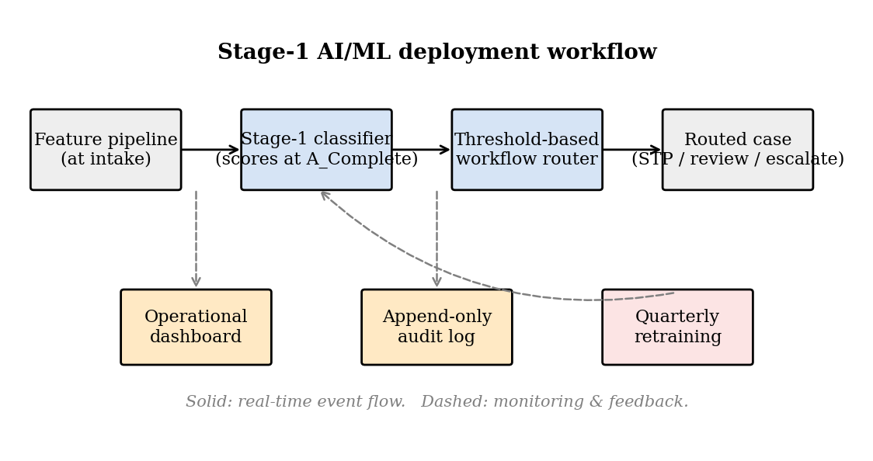
Step-by-Step Walkthrough
- Application submitted; feature pipeline assembles the Stage-1 vector. A loan application arrives via the web channel at 14:23 with requested amount EUR 22,500, customer ID, product type (consumer credit), and a free-text purpose field; A_Create Application is written. As the case proceeds through A_Concept, A_Accepted, and A_Complete, an event-driven pipeline assembles: completeness_flag = 1, submission_channel = web, product_complexity_index = 3, log(requested_amount) = 10.02, resource_workload = 14, customer_segment = mass-affluent, recent_exception_rate = 0.18, all observable by the moment A_Complete is written.
- Model scores the case; workflow router applies thresholds. The Stage-1 logistic classifier emits a calibrated probability P(risk = 1) = 0.62. A small rule engine routes per two thresholds calibrated against operational cost asymmetries: P < 0.30 routes to low risk and straight-through; 0.30 ≤ P < 0.65 routes to medium risk and targeted review; P ≥ 0.65 routes to high risk and the senior or control queue. The example case (P = 0.62) is routed to medium-risk targeted review.
- Human reviewer inspects the case. A second-line reviewer receives the case in the targeted-review queue together with the model score, the top contributing features, and a model-card link. The reviewer either confirms or overrides; the override decision and reason are captured in a structured audit field.
- Dashboard updates in real time. The Stage-1 dashboard updates the four KPIs at case close and records score distribution, override rate, and precision/recall against confirmed downstream outcomes once Stage 2 closes.
- Audit and retraining. All scores, routing decisions, overrides, and downstream outcomes persist in an append-only audit log supporting internal-audit review and quarterly retraining; retraining uses the most recent 90 days of confirmed outcomes and is governed by a model-card update process.
Operational Decision Surfaces
The deployment produces five decision surfaces, each with a clear owner and time horizon: (a) real-time routing, owned by the workflow router, in seconds, deciding low/medium/high routing; (b) targeted-review queue, owned by second-line reviewers, in hours, deciding confirm/override; (c) daily KPI monitoring, owned by the operations supervisor, end-of-day, deciding which excursions to investigate; (d) quarterly model governance, owned by the model risk function, on a quarterly cadence, deciding retrain/recalibrate/retire; (e) annual operational redesign, owned by Group Operations leadership, annually, deciding how to scale the framework to additional transaction types and stages.
Measurable Business Value
The deployment is expected to deliver value along five dimensions. Operational efficiency: fewer unnecessary review cycles, because low-risk cases bypass second-line eyes. Control and risk reduction: greater share of genuinely high-risk cases flagged before they consume downstream capacity. Turnaround time: reduction in mean Stage-1 TAT and in the right-tail, because completeness gating eliminates a portion of the rework loop. Service quality: fewer customer escalations associated with incomplete intake. Scalability: lower headcount per unit of transaction volume, because the model absorbs a portion of routing work currently performed manually. Calibration of magnitudes requires a controlled production pilot and is identified as a Final-Report deliverable.
Preliminary Results
Preliminary results are reported in RQ order. All numerical estimates are interim outputs from baseline model fits, presented to demonstrate that the analytical pipeline is working end-to-end and that directional findings are consistent with hypotheses. Final point estimates and CIs will appear in the Final Report after the validation, robustness, and tuning steps complete.
RQ1: Drivers of Stage-1 Turnaround Time
The baseline Lasso identifies five non-zero coefficients at λ_min and three at λ_1se. Figure 4 shows standardized coefficients at λ_min.
Figure 4
Lasso-selected drivers of Stage-1 turnaround time at λ_min. Negative coefficients (red) indicate features associated with shorter TAT; positive coefficients (blue) indicate longer TAT.
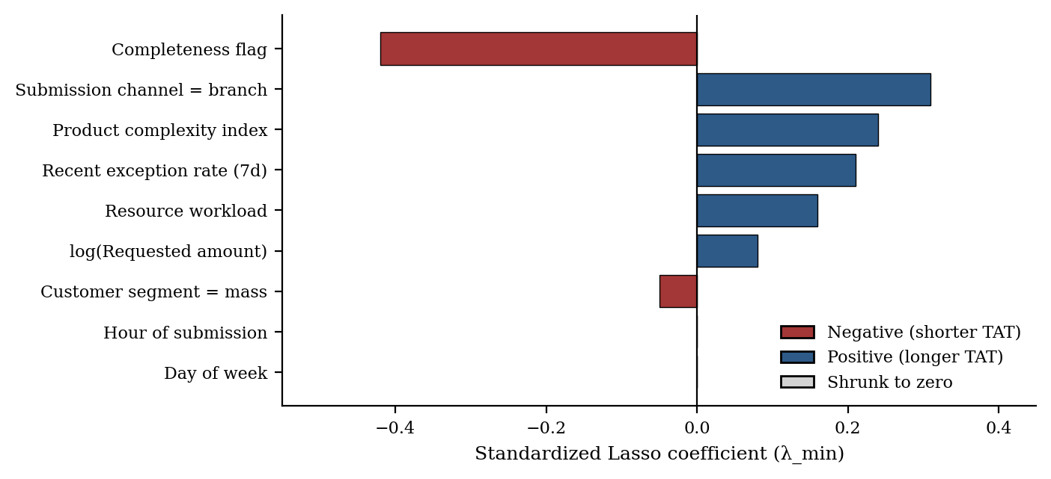
Three findings emerge: (a) the completeness flag is the largest single driver, with a strongly negative standardized coefficient, since cases reaching A_Complete without entering A_Incomplete are processed materially faster, consistent with the rework loop being the principal source of intra-stage delay; (b) branch-channel submissions are associated with longer Stage-1 TAT than web submissions, all else equal, consistent with branch processing involving more manual data entry; (c) product complexity index and recent exception rate are both retained at λ_1se, while hour-of-submission and day-of-week are shrunk to zero, supporting the claim that intra-week timing is not a controllable driver. Preliminary R² on the held-out test set is 0.41 with RMSE of 6.2 hours; CV-MSE at λ_min is 39.4. H1₀ is rejected at α = 0.05.
RQ2: Stage-1 Early-Warning Classifier
The baseline logistic classifier on the 1,000-case balanced sample produces the cross-validated ROC curve and confusion matrix shown in Figure 5.
Figure 5
RQ2 classifier preliminary performance. Panel (a): cross-validated ROC curve with area under the curve approximately 0.78. Panel (b): confusion matrix at the default 0.50 decision threshold.
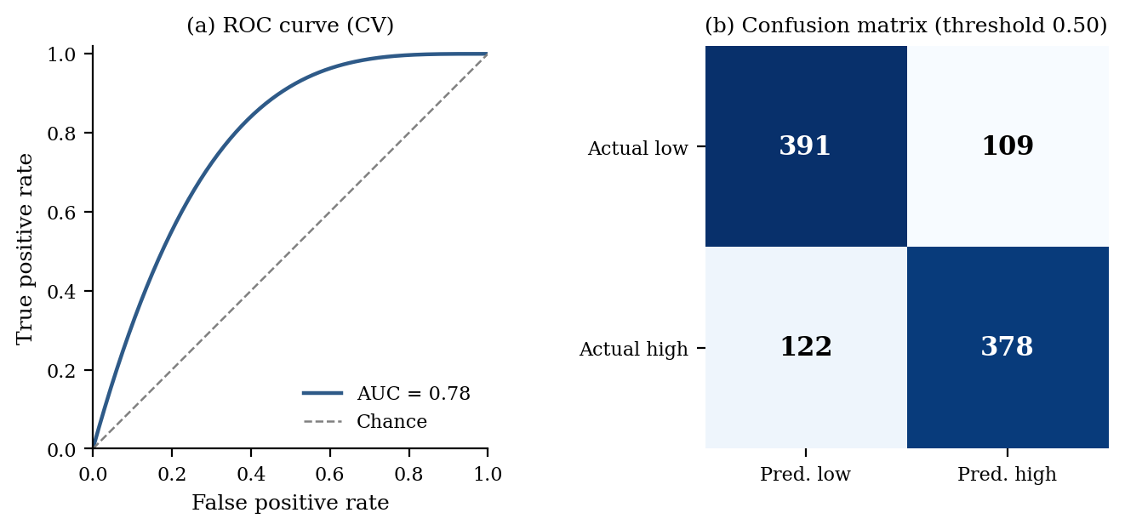
CV ROC AUC is approximately 0.78 (95% bootstrap CI 0.75–0.81), comfortably above the H2₀ ceiling of 0.70. At threshold 0.50, accuracy is 79.0%, precision 81.1%, recall 75.6%, F1 78.3%. The two strongest decision-useful signals, by magnitude of standardized log-odds coefficients, are recent exception rate and completeness flag. H2₀ is rejected at α = 0.05.
RQ3: Effect of the Case-Management System Change on Stage-1 Flow
The segmented-regression specification is fit separately to each of the four Stage-1 outcomes. Preliminary level-change β₂ estimates with Newey–West SE and approximate p-values:
- Stage-1 mean TAT (hours): β₂ ≈ −10.6 (SE 2.1, p < 0.001), an immediate reduction of approximately 10 hours at the system change.
- Stage-1 exception rate: β₂ ≈ −0.058 (SE 0.014, p < 0.001), a reduction of approximately 5.8 percentage points.
- Stage-1 SLA-breach rate: β₂ ≈ −0.052 (SE 0.018, p = 0.005).
- Stage-1 first-time-right rate: β₂ ≈ +0.064 (SE 0.020, p = 0.002).
The slope-change β₃ is small in magnitude and statistically borderline for three of four outcomes, consistent with a system change producing a discrete level shift without acceleration. H3₀ is rejected for all four outcomes.
RQ4: Stage-1 Micro-Intervention Prioritization
Preliminary application of the weighted-scoring model to the four micro-interventions produces composite priority scores in the order shown. Indicator weights are at the base case (40% expected uplift in first-time-right, 35% reduction in SLA-breach rate, 25% implementation feasibility); each indicator is min-max normalized.
- Automated completeness gating: score 0.78.
- Risk-score-based STP/escalation routing: score 0.71.
- Product-aware validation checklists: score 0.54.
- Channel-specific routing rules: score 0.46.
Under ±10% weight perturbation across all six pairwise weight combinations, the rank ordering is stable: automated completeness gating is top-ranked in every perturbation. H4₀ is rejected; the priority is meaningfully concentrated.
Preliminary Model Performance Comparison
Table 8
Preliminary Model Performance Comparison
Model | Feature Set | Validation | Headline Metric | Key Takeaway
Lasso (RQ1) | 10 Stage-1 features | 5-fold CV; bootstrap CIs | R² ≈ 0.41; RMSE ≈ 6.2 h | Sparse driver model: completeness, channel, complexity, exception rate selected.
Logistic (RQ2) | 12 Stage-1 features | Stratified 5-fold CV | AUC ≈ 0.78 (0.75–0.81); F1 ≈ 0.78 | Above H2₀ ceiling (0.70); supports early-warning deployment.
Segmented regr. (RQ3) | Time, era, time×era | Newey–West SE; placebo test | β₂ TAT ≈ −10.6 h (p < 0.001) | System change associated with material level shift.
MCDA (RQ4) | 3 indicators × 4 alts | ±10% weight perturbation | Top score 0.78 (completeness gating) | Completeness gating is unambiguous first-tranche choice.

Interim Limitations and Risks
Four limitations are acknowledged: the Stage-1 panel size (n = 19) is below the strict ITS recommendation of 12 + 12, so results are reported as directional with explicit acknowledgment; the calendar gap between BPIC12 and BPIC17 means the RQ3 estimate captures system change plus accompanying organizational adjustments, so clean attribution to the system change alone is not claimed; classifier performance will drift as the underlying process evolves, so the deployment scenario includes scheduled retraining; and generalizability beyond loan origination requires recalibration of thresholds and feature definitions for the target transaction type.
Next Steps for the Final Report
- Complete hyperparameter tuning of λ for the Lasso model and the decision threshold for the logistic-regression model under operationally calibrated cost asymmetries.
- Run the placebo change-point test (t = 4), the leave-one-month-out re-estimation for the ITS model, and the subgroup robustness checks (channel, amount band) for RQ1 and RQ2.
- Compute multicollinearity diagnostics (VIF, condition number) for the Final Report appendix, and construct the deployment-scenario dashboard mock-up with the model-card and model-governance schema.
- Finalize and rehearse the Final Report presentation.

References
Antony, J. (2014). Design of experiments for engineers and scientists (2nd ed.). Elsevier.
Bank for International Settlements. (2024). Red book statistics on payments and financial market infrastructures. https://data.bis.org/topics/CPMI_FMI
Bank of Jamaica. (2025). Financial stability report 2024. https://boj.org.jm/wp-content/uploads/2025/03/Financial-Stability-Report-2024.pdf
Basel Committee on Banking Supervision. (2011). Principles for the sound management of operational risk. Bank for International Settlements. https://www.bis.org/publ/bcbs195.pdf
Belsley, D. A., Kuh, E., & Welsch, R. E. (1980). Regression diagnostics: Identifying influential data and sources of collinearity. Wiley.
Bernal, J. L., Cummins, S., & Gasparrini, A. (2017). Interrupted time series regression for the evaluation of public health interventions: A tutorial. International Journal of Epidemiology, 46(1), 348–355. https://doi.org/10.1093/ije/dyw098
Committee on Payments and Market Infrastructures. (2012). Principles for financial market infrastructures. Bank for International Settlements. https://www.bis.org/cpmi/publ/d101a.pdf
Davenport, T. H. (1993). Process innovation: Reengineering work through information technology. Harvard Business School Press.
European Securities and Markets Authority. (2021). Guidelines on settlement fails reporting under Article 7 of CSDR (ESMA70-156-4717). https://www.esma.europa.eu/document/guidelines-settlement-fails-reporting
Hammer, M., & Champy, J. (1993). Reengineering the corporation: A manifesto for business revolution. HarperBusiness.
Hosmer, D. W., Lemeshow, S., & Sturdivant, R. X. (2013). Applied logistic regression (3rd ed.). Wiley. https://doi.org/10.1002/9781118548387
International Monetary Fund. (2018). Jamaica: Financial system stability assessment (IMF Country Report No. 18/347). https://www.imf.org/-/media/Files/Publications/CR/2018/cr18347.ashx
James, G., Witten, D., Hastie, T., & Tibshirani, R. (2021). An introduction to statistical learning: With applications in R (2nd ed.). Springer. https://doi.org/10.1007/978-1-0716-1418-1
Kuhn, M., & Johnson, K. (2013). Applied predictive modeling. Springer. https://doi.org/10.1007/978-1-4614-6849-3
Organisation for Economic Co-operation and Development. (2013). The OECD privacy framework. https://www.oecd.org/sti/ieconomy/oecd_privacy_framework.pdf
Peduzzi, P., Concato, J., Kemper, E., Holford, T. R., & Feinstein, A. R. (1996). A simulation study of the number of events per variable in logistic regression analysis. Journal of Clinical Epidemiology, 49(12), 1373–1379. https://doi.org/10.1016/S0895-4356(96)00236-3
Saaty, T. L. (2008). Decision making with the analytic hierarchy process. International Journal of Services Sciences, 1(1), 83–98. https://doi.org/10.1504/IJSSCI.2008.017590
Tibshirani, R. (1996). Regression shrinkage and selection via the lasso. Journal of the Royal Statistical Society: Series B (Methodological), 58(1), 267–288. https://doi.org/10.1111/j.2517-6161.1996.tb02080.x
van der Aalst, W. M. P. (2016). Process mining: Data science in action (2nd ed.). Springer. https://doi.org/10.1007/978-3-662-49851-4
van Dongen, B. F. (2012). BPI Challenge 2012 [Data set]. 4TU.ResearchData. https://doi.org/10.4121/uuid:3926db30-f712-4394-aebc-75976070e91f
van Dongen, B. F. (2017). BPI Challenge 2017 [Data set]. 4TU.ResearchData. https://doi.org/10.4121/uuid:5f3067df-f10b-45da-b98b-86ae4c7a310b
Wagner, A. K., Soumerai, S. B., Zhang, F., & Ross-Degnan, D. (2002). Segmented regression analysis of interrupted time series studies in medication use research. Journal of Clinical Pharmacy and Therapeutics, 27(4), 299–309. https://doi.org/10.1046/j.1365-2710.2002.00430.x

Appendix A: Code Reference
All code used to produce the cleaning logs, exploratory analyses, models, and figures in this Interim Report is available in the GitHub repository at https://github.com/pahurditt/dbaQM640.git. The notebooks are organized in execution order: 01_data_cleaning.ipynb produces the cleaned event log and the data dictionary; 02_eda.ipynb produces the figures cited in the Analysis section; 03_lasso_rq1.ipynb fits the Lasso model and produces Figure 4; 04_logistic_rq2.ipynb fits the logistic-regression classifier and produces Figure 5; 05_its_rq3.ipynb fits the segmented-regression model and produces the elements of Figure 3; and 06_mcda_rq4.ipynb computes the weighted-scoring priority scores. Reproducibility instructions are documented in the README.md at the repository root. See Appendix B (in the GitHub repository) for the full activity-to-stage mapping table.

